Name _____________________________________
Total War on the Home Front during World War I

 | Image Analysis | Notes from Learning Stations | Notes from Class
Factories | IMAGE: Based on the images, how were factories impacted by World War I? | - In what ways did the government become involved in the economy during the war?  - What happened to unemployment during the war?  - How were neutral countries affected by the war? | - During World War I, both the Allies & Central Powers committed to _____________________________:  - To produce necessary war equipment, governments took greater _______________________________ of the economy, converted factories to wartime production, & set production ____________  - All available citizens were ________________________________; Unemployment in Europe nearly ___________________  - Neutral countries like the USA were able to __________________ by trading with countries at war
Conscription | IMAGE: According to the chart, which county mobilized the most soldiers?  What is the poster requiring men to do? | - What is conscription? Why was is necessary during the war?  - Which men had to register for the draft?  - Why do you think that people stopped volunteering to join the army by 1916? | - In order to supply to front lines with enough soldiers, governments used conscription, a military ___________________________ that required men to _____________________  - At first men _________________________________ for the war, but by 1916, people began to realize how “_____________” the war was & volunteers __________________________________  - Governments had to _________________ soldiers because there were not enough troops  - Men __________ had to register and there was a _____________ for soldiers that would have to report for duty
Propaganda | IMAGE: What are these posters trying to get people to do? | - What is propaganda?  - What types of things did propaganda posters ask civilians to do during the war?  - Why were civilians so important to the war effort? | - During World War I, nations used __________________ information called propaganda to maintain civilian ________________________ for the war  - Propaganda played an important role in maintaining the support of the _________________________ for the war effort & helped ___________________ soldiers  - Propaganda _________________________ & slogans asked that civilians “________________________________” by participating in conscription, rationing, & __________________________ sales  - In addition, most governments ____________________________ the media to control war information

 | Image Analysis | Notes from Learning Stations | Notes from Class
Rationing | IMAGE: What are the common themes among these posters? | - What is rationing?  - In what ways were civilians impacted by rationing?  - How was World War I different from all other wars, in regards to the level of commitment that was asked of the civilians? | - Throughout the war, resources became _______________________ so governments began using rationing  - Rationing programs allowed people to use only ______________ amounts of essential resources, like ___________ & __________  - Governments ________________________ supplies & resources to the soldiers on the front and controlled __________________ of goods at home  - Civilians needed ___________________ to be able to buy goods; Many people grew _____________________________________ to support rationing programs
Role of Women | IMAGE: According to the images, how could women support the war effort? | - In what types of work were women employed in during the war?  - What roles did women play in the military?  - How were women affected when the war ended? | - Women’s roles changed during World War I  - During the war, ____________________ replaced men in heavy industry & ___________________________________ factories  - This type of work was not seen as “_______________________” for women, but was a ___________________________ solution to ensure that enough weapons were made  - In addition, women served as ____________________, drivers, clerks for the __________________________________ & were encouraged to support their husbands if they were drafted or _____________________________
Financing the War | IMAGE: Based on the statistics, which side should have won the war? Why?  What is the goal of the propaganda poster? | - How did the role of government change during the WWI?  - How did governments attempt to pay for the war?  - What was the total “cost” of the war? | - Fighting in WWI required governments to raise _________________ of dollars  - New government __________________________ were created to manage the war, soldiers were _______________________, military _________________________ were made with factories  - These programs were _________________________________ & required creative ways to pay for war expenses  - Governments sold ___________________________ that offered citizens investments that would be ________________________ at a later time

Identify the 6 images as being related to the “Battlefront” or “Homefront”. Then explain how each illustrates the concept of Total War.
 | Image 1 | Image 2 | Image 3 | Image 4 | Image 5 | Image 6
Battlefront or
Homefront?
How does it
Reflect Total War?

Factories
World War I soon became a total war. This meant that countries devoted all their resources to the war effort. In Britain, Germany, Austria, Russia, and France, the entire force of government was dedicated to winning the conflict. In each country, the wartime government took control of the economy. Governments told factories what to produce and how much. Numerous facilities were converted to munitions factories. Nearly every able-bodied civilian was put to work. Unemployment in many European countries all but disappeared.

When WWI first broke out, there were shortages of essential goods. Britain faced a shortage of munitions shells. They had to form the Ministry of Munitions to control production and had considerable success. Factories produce more war supplies faster and a year's worth of pre-war production of light munitions could be completed in just four days by 1918. Aircraft production in 1914 provided employment for 60,000 men and women; and by 1918 British companies employed over 347,000.

When Europe’s production was falling because of the fighting, the US’s industry was booming. Factories had to increase production to keep up with the pace of the war. New technologies help increase production and women and African-Americans were able to gain jobs of the men that were off fighting. After the war, when soldiers returned home, many women stopped working.
Factories

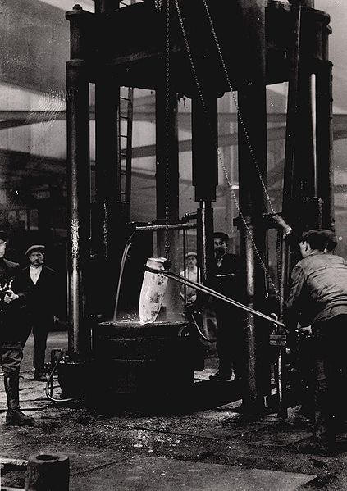
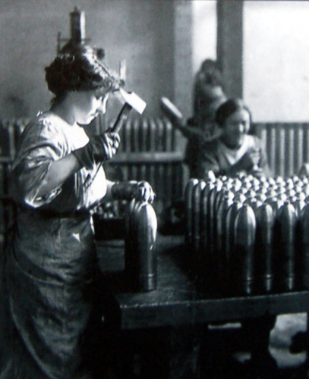

Conscription

When World War I began, many citizens were enthusiastic about joining the war and volunteered for military service. The British Army gained 2.67 million soldiers as a result of volunteers. But as the war went on and the devastation from the front led to more and more casualties, governments found it harder to find more volunteers to join the army. As a result, governments of the Allies and Central Powers passed conscription laws to draft citizens into the army.

These conscription laws required people to join the army if their names were selected. Men from the ages of 18-50 were required to register with the draft board and were assigned a draft number. When the government needed soldiers, numbers were randomly drawn and men were called upon to fight in the war. In addition, imperial powers called upon their colonies to help in the struggle. Fighting troops as well as laborers came from India, South Africa, Senegal, Egypt, Algeria, and Indochina. Many fought and died on the battlefield. Others worked to keep the front lines supplied.

Some people objected to their conscription. Some men refused to participate in military service and were sent to prison. Others refused to fight because they thought that war was wrong but they were willing to go to the Western Front and act as stretcher-bearers. Many of these objectors were killed doing this job.

Conscription

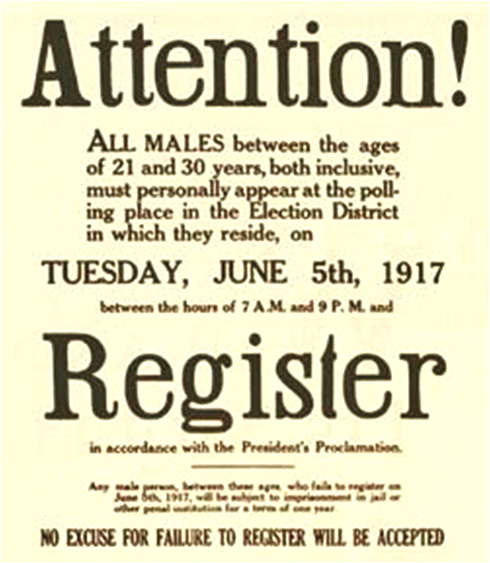

Total Mobilized Troops
(in millions)
British Empire | 9.5
France | 8.2
Russia | 13
Italy | 5.6
United States | 3.8
Other Allies* | 2.6
Total Allied Forces | 40.7
Germany | 13.25
Austria-Hungary | 9
Bulgaria, Turkey | 2.85
Total Central Powers | 25.10
*Belgium, Romania, Portugal, Greece, Serbia

Propaganda

During World War I, governments also used propaganda, one-sided information designed to persuade, to keep up morale and support for the war.

Propaganda was used to explaining to their own people why the nation was involved in the war. Emotional and patriotic posters were used to recruit men to fight and to convince citizens to buy war bonds (loans to the government) in order to raise enough money to fight the war. Posters commonly urged wartime savings and conservation in order to guarantee that the military would have enough resources to fight the war.

Propaganda increased feelings of nationalism and patriotism during the war, but governments also censored the media. They suppressed negative news about the war. Many leaders feared that honest reporting of the war would turn people against it. Governments suppressed anti war activity, sometimes forcibly by arresting anti-war protestors and keeping them jailed during the course of the war.

Interestingly, even though the U.S.A. joined the war relatively late in April 1917, she produced many more propaganda posters than any other single nation. Because governments need the help and support of ALL people, propaganda helped them to manage the home front.

Propaganda
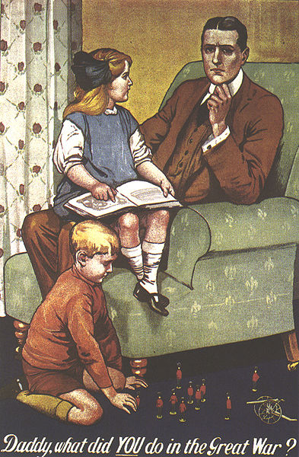
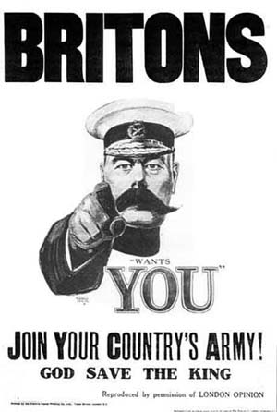

Rationing

One challenge that governments faced was how to handle the distribution of resources, food in particular. So many goods were in short supply that governments turned to rationing. Under this system, people could buy only small amounts of those items that were also needed for the war effort. Eventually, rationing covered a wide range of goods, from butter to shoe leather.

Germany begun rationing early in 1915, first with bread and then extended in the same year to potatoes and meat and finally to nearly every essential food product. The rationed items could be obtained only on tickets, in specified amounts and at prices fixed by the government. This also later applies to important resources that were needed for the soldiers or the production of weapons and supplies, such as gasoline, iron, and glass.

Throughout the war, civilians were being asked to “do your part” to help out in the war effort. Most citizens supporting government rationing programs and began growing “victory gardens” so they could produce their own vegetables. These victory gardens helped governments divert needed food to the soldiers in the trenches.

Rationing

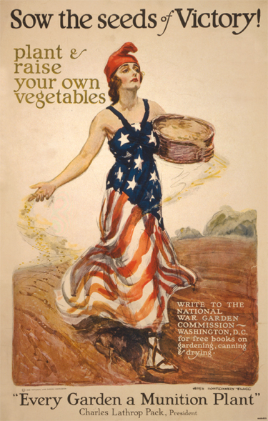
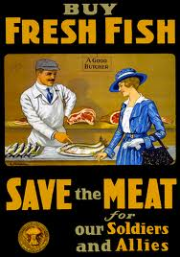

Role of Women

Total war meant that governments turned to help from women as never before. Before the war, women were employed in traditionally female jobs including domestic servants, teaching, nursing, office work, textile factories. When war broke out in August 1914, thousands of women replaced men in factories, offices, and shops. Women built tanks and munitions, plowed fields, paved streets, and ran hospitals. They also kept troops supplied with food, clothing, and weapons. Many women were paid good wages, especially in munitions factories, but in most cases they were paid less than men.

Women gained jobs in the military as well, where they worked as clerks, secretaries, drivers, and typists. Women were in great demand for the ‘caring’ side of employment and became nurses in the First Aid Nursing Yeomanry and the Red Cross. In addition, propaganda posters encouraged women to support their husbands and fathers when they were drafted or volunteer for military service.

Women were seen as temporary workers that would be used for the ‘duration of the war’. Although most women left the work force when the war ended, they changed many people’s views of what women were capable of doing. Women also saw the horrors of war firsthand, working on or near the front lines as nurses.

Role of Women
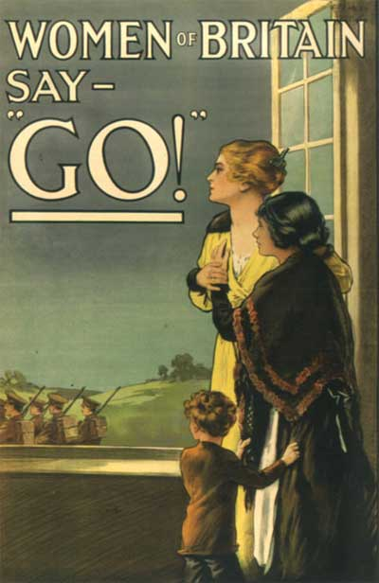
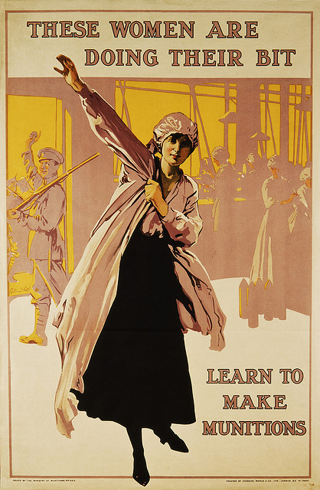
Financing the War

World War I changed the role of the government dramatically because so much effort was needed to win the war. Governments became more involved as a way of supporting the war and they needed money to be able to pay for the war. The size of government of the nations at war grew in order to meet the demands of the war. For example, the United States created over 5,000 new bureaucratic agencies such as the War Industries Board which oversaw the production of military equipment and the Food and Fuel Administrations to oversee rationing programs that provided resources to the military. The government signed expensive military contracts with factories to create new munitions and weapons. The millions of soldiers who volunteered or were drafted were given service pay for their war duty. These programs were very expensive.

One movement that raised a large amount of money was the sale of war bonds. These certificates are investments that people can buy that the government will pay back later. For example, the cost for the United States was $32 billion. To raise money to pay for the war, the U.S. government sold war bonds which generated $23 billion. An additional $10 billion was generated by raising income taxes on citizens and companies.

One of the impacts of the war was the cost involved, in terms of human lives and money. The long term impact of the war on all nations that became involved had a tremendous impact on the world.
Financing the War


