Name: __________________________________________________ Date: ___________________________
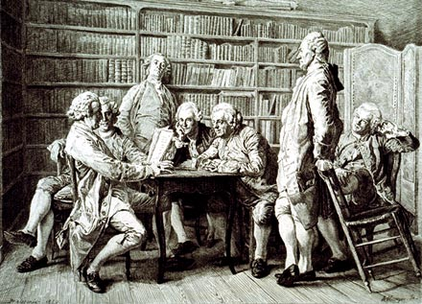

The Age of Enlightenment

During the 1700's, European philosophers thought that people should use reason to free themselves from ignorance and superstition. They believed that people who were "enlightened" by reason could perfect themselves and society. As a result, this period is often called the Enlightenment. Among the most prominent of the Enlightenment philosophers were Thomas Hobbes, John Locke, Jean-Jacques Rousseau, and Baron de Montesquieu.
The Enlightenment may be seen as a product of the vast changes that took place in Europe during the sixteenth and seventeenth centuries, during the Renaissance, the Reformation, and the Scientific Revolution. These changes produced the social values that permitted the Enlightenment to sweep through Europe in the late seventeenth and eighteenth centuries. The Enlightenment had its foundation in three new theories about human beings: 1) Individualism stressed the importance of the individual and his rights as a citizen; 2) Relativism consisted of the concept that different ideas, cultures, beliefs, and value systems had equal merit; 3) Rationalism was the conviction that using the power of reason, humans could arrive at truth and make progress toward improving human life.
During the 1700's, Enlightenment ideas spread across Europe and the Atlantic to the Americas. Through books and newspapers, in coffeehouses and at informal gatherings, people heard the call for reform. Some of Europe's rulers even supported Enlightenment ideas. In some nations, these "enlightened monarchs" ended serfdom and allowed religious freedom.
During the Enlightenment, or Age of Reason, intellectuals began to examine the standards by which rulers governed. The principles of this time held that everything, including the government, was worth examination and scrutiny. These principles spread to our early political scientists. These new liberal ideas stated that individuals had natural rights and that government was an agreement or contract between the people and their ruler. In this governmental contract both the ruler and the citizen had rights and responsibilities. Power needed to be separated and balanced so that individuals or groups did not become corrupt through those powers. The people wanted a change from absolutism and the divine right of kings to constitutionalism. Constitutionalism was the belief that the government contract should be written down, making clear what powers were given to whom The philosophers believed that the government "contract" and its supporting laws needed to reflect the "general will" of the people. Laws should be agreed upon by both the ruler and those governed. Assemblies of citizens should be formed with real power to influence the government and judge whether rulers acted properly.
Rulers and governments which abused their power and did not protect the rights of the citizens were corrupt and the people had a right to rebel and replace the ruler. The ruler also had the right to expect that the citizens would respect the government and laws which were just. After the American Revolution and the French Revolution, more and more countries began to write constitutions which reflected these liberal ideas. Political theorists or thinkers further examined how to determine if the laws or rules of government really reflected the "individual rights" of the citizens and the "general will" of the people. It became accepted that legislation and justice ought to reflect what was the best for the most people, or the greatest good for the greatest number. Discussion and debate on exactly who was a citizen and had the right to take part in the new governments continued to grow. Discussions on slavery, women's rights, and discrimination continue today.

Task #1: Read the resource cards and primary sources for each Enlightenment Philosophers discuss the questions with your partner/group and answer the following questions using the documents and your knowledge of the Enlightenment.

1. What is the difference between the “state of nature” and “civil society”? Which would you rather live in and why?

2. Do you agree more with Hobbes’ or Locke’s view of the nature of man? (Is man inherently good or inherently bad?) Why? If man is inherently good, how do you account for laws, prisons, the death penalty, etc…? If man is essentially bad, what does the future hold?

3. What are the pros and cons of Montesquieu’s concept of divided government?

4. What (do you think) is meant by “pursuit of happiness”?

5. According to the philosophers, what are “inalienable rights” and how would you define YOUR “inalienable rights” in this classroom and school?

6. What is your opinion of Locke’s idea that if a government denies people basic rights then the people have the right to change the government? Has this happened anywhere in the world throughout history? If so, when and where?

Task #2: Using the readings & primary sources, complete the chart below and questions that follow:

Liberty – 1 the state of being free within society from oppressive restrictions imposed by authority on one's way of life, behavior, or political views :
2 the power or scope to act as one pleases : individuals should enjoy the liberty to pursue their own interests and preferences.

Philosopher | What is the Role & Responsibility  of government with respect to its citizens? | How would each philosopher define Liberty?
Hobbes

Locke

Rousseau

Montesquieu

a. Which philosophers definition of liberty do you most agree with and why?

b. Which of the four philosopher’s ideas about government appeal to you most and why?

Task #3: Analyze the following 17th & 18th century European political cartoons and answer the questions that follow. There are captions & explanations of the cartoons on the page following the cartoons.

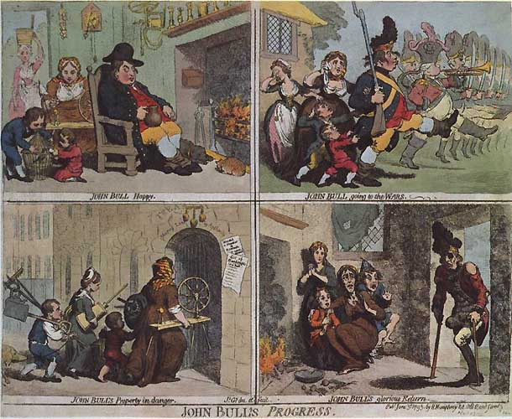

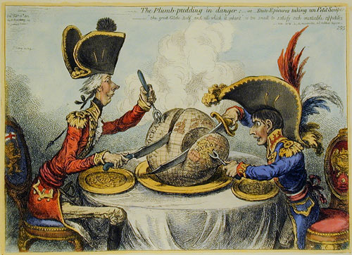

1.

2.

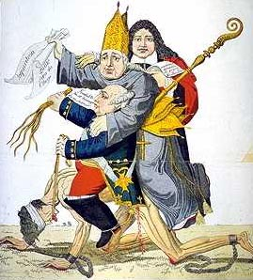
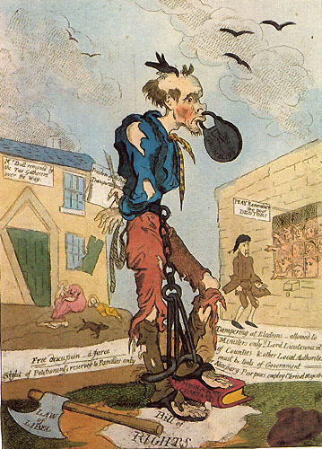

3.
4.
Cartoon captions & explanations:
1. James Gillray, "John Bull's Progress" (1793): Here Gillray uses "John Bull," the symbolic Englishman, to describe a social ill in Britain. Starting from the upper left, we see "John Bull Happy." Next, we see "John Bull going to the wars." Then, it is "John Bull's Property in Danger"—his impovershed family brings its belongings to the pawn shop. Finally, "John Bull's glorious Return" reveals a one-legged John Bull returning to his pauperized family which now subsists on onions.

2. James Gillray, "Plumb Pudding in Danger" (1805):

3. Europe in the 17th century. It represents a peasant carrying on his back a clergy member, and a nobleman.

4. An 18th century British cartoon, George Cruikshank, "A Free Born Englishman! The Admiration of the World!!! And the Envy of Surrounding Nations!!!!!" (1819): This pathetic figure stands on the Bill of Rights with one foot and the Magna Carta with the other. Behind him, a tag states: "Free discussion—a farce. Right of Petitioning, reserved to Families only." In his hand, he bears a note: "Freedom of the Press—Transportation" (meaning transportation to Australia as a convict).

What social issues/problems are shown in each of the four Enlightenment era political cartoons?
1.

2.

3.

4.

What would Hobbes, Locke, Rousseau, and Montesquieu each have to say about these social ills?
Hobbes | Locke
Rousseau | Montesquieu

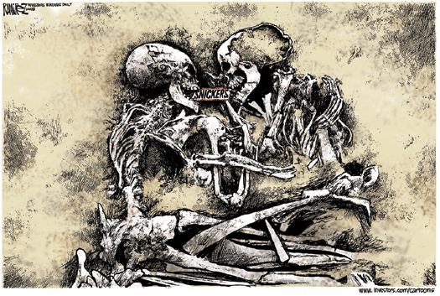

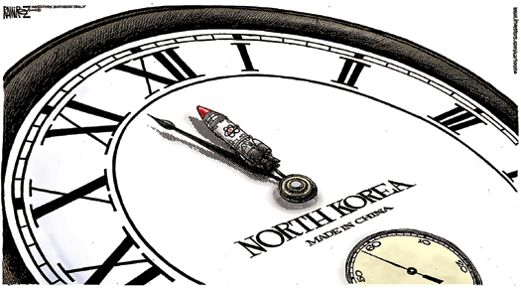

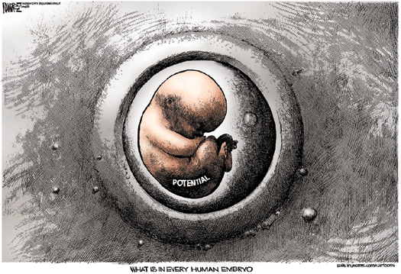

What social issues/problems are shown in each of the four modern-day political cartoons?
1.

2.

3.

4.

What would Hobbes, Locke, Rousseau, and Montesquieu each have to say about these social ills?
Hobbes | Locke
Rousseau | Montesquieu

Task #4: Metaphor

Was the Enlightenment more like a hurricane, musical, or waterfall? Explain.
Task #5: You have a choice: (Using toondoo.com or bitstrips.com), You can create a four frame comic strip that illustrates each of the four Enlightenment philosophers and their beliefs. One frame for each philosopher. YOU MAY NOT USE ANY WORDS, only pictures to illustrate the ideas.

