Ancients Theme Park

World History Project

**The Task**:

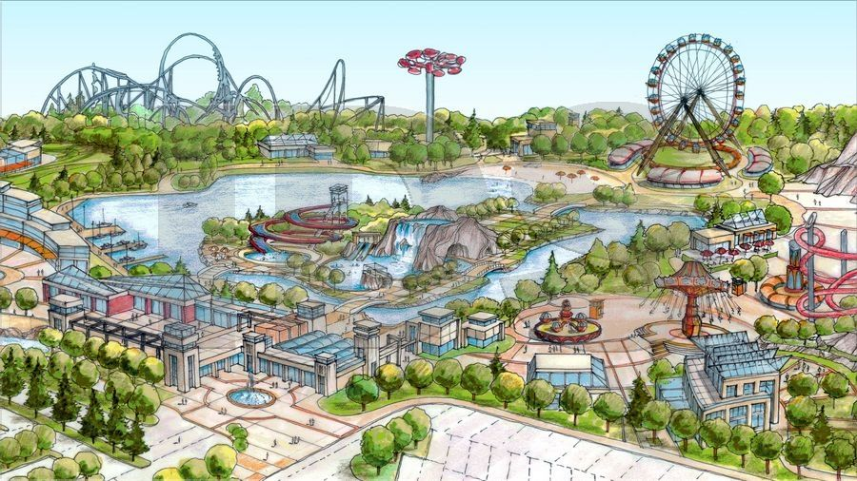Each class will be creating a Theme Park made up of up to 7 "Lands," representing either geographical regions and/or time spans in history. Groups of 4-5 students assigned to the various Lands will develop 1-2 rides or attractions designed to reflect some aspect of the history of their region or period, and will develop an advertising campaign to show what park-goers can expect to learn from their visit. Finally, the groups will construct a 3-dimensional model of their section of the park, which will be joined to the sections belonging to the other groups in their class to create a Theme Park of distinct "Lands," *a la* Disney World, etc. Overseeing the operation will be 1-2 Park Administrators, students whose role it is to coordinate classwide efforts and act as liaison between the engineers and the shadowy Big Boss Man, whose investment capital is making the whole project possible.

**Competition & Compensation**:

Rivalry is fierce in the amusement park industry, but great wealth and reward await the "Imagineers" who work well in both large and small teams. Students will receive group grades for the project, and will provide confidential feedback on one another's performance that could serve to modify the group grade.

The project is worth 225 points – 50 for the design and construction of your group’s Land; 50 for the posters/pamphlets; and 50 for the group’s presentation of its Land to the class, 50 points for the group’s PERSIA chart, and 25 points for each student’s evaluation. Students should establish at least ONE leader that meets their leadership criteria and employ at least ONE primary document (available at end). A more detailed breakdown of points is outlined below.

**Project Components & Timeline:**

1. *Groups* Groups will consist of 4-5 students, and will be assigned one of the following "Lands:"Groups may rename their lands (eg, to fit with a class-developed theme), so long as their broader meaning is not lost.

Persia Land

-be on the other side of the 300!

Egypt Land

-Pyramid theme, visit the Book of the Dead horror ride

Indus Land

-Battle Shiva, act like a Brahmin

The Silk Road Land

-ride a camel, buy silk

Greek Land

-Gods roller coaster, try your hand at Olympic sports

Roman Land

-Gladiators! Roman engineering water ride

Kush Land

-look for salt and gold

Mayan Land

- The Quetzalcoatlcoaster

Jerusalem Land

-visit the ancient temple

2. *Park Administrator* Classes should choose one leader who will serve as

the FDR to their New Deal. The Park Administrator will facilitate a class discussion about what the final project should look like, monitor group progress and use of class time during the research and construction phases, and coordinate with the Big Boss Man on a regular basis for the duration of the project. This is a position of no mean responsibility – classes are strongly advised to appoint leaders who will get the job done, not goofballs who need a few extra credit points.

3. *Brainstorming* Groups are to brainstorm important aspects of their time frame/region, and how these might be best represented by a theme park ride. Remember that you're communicating knowledge, not just a weird ride. Finally, each Land's attractions must fit into one of the following themes, and include rides that represent at least 2 n PERSIA themes (exploring three themes is preferred). RELIGION should be analyzed in the following categories:

1. founder (s)  
2. Holy Books/places  
3. symbols  
4. doctrine/practices  
5. festivals/holidays  
6. afterlife  
7. divisions/population  
8. role of women

The theme selected should inform the way group presents a particular attraction – the aforementioned Quetzalcoatlcoaster, for example, might look different if it were presented under an Engineering theme rather than a Religious one.

4. *Class Discussion* Facilitated by the Park Administrator, the class will

discuss its options with regard to an overall theme for the park. Should it have an overriding focus, like war or a bent toward the macabre, or should it be a more Disney-like hodgepodge? What standards will be applied toward the modeling, and will there be any effort at uniformity of message?

5. *Research & Design* For each of its three attractions, each group must create a

colorful, one-sided poster or pamphlet describing the main points about the attraction as well as notes about what it's trying to teach. This work should be done parallel to the design and construction phases of the modeling component; the posters will form part of the display when the class project is assembled.

6. *Construction* Groups will assemble a 3-D representation of their Land on a base measuring approximately 24"x36" (or about half a large- sized sheet of foam board or poster paper); this will form part of the base of the park, and it will interlock with other sections in the class to form the finished product. Coloring and/or texturing of bases is a class or group decision – some may choose to work in papier-mâché relief, while others might prefer to allow groups to color stuff however they want.

The Big Boss Man will fund standard art supplies – glue, markers, scissors, etc., but nothing exotic. This project is what you make of it, and is not simply a matter of assembling parts.

7. *Final Product* In the end, students will have produced:

1. a 3D rendering of a theme park "Land" containing 1-2 attractions related to an historical period/region and theme.

2. 1-2 posters advertising the attractions and giving reasons why the things they portray are historically important

3. a compelling presentation that makes the students’ peers and teacher want to visit their section of the Theme Park

4. A completed Persia Chart for the civilization, primary source, and designated Leader analysis.

***Rubrics and other documentation will be forthcoming. For now, consider the history and possibilities of the Land to which you've been assigned – and build something that will stand the test of time!***

*Planning* Use this space for design notes, sketches, etc.: