http://www.veronicasicoe.com/blog/2013/04/utopia-and-dystopia-Utopia and Dystopia – The Many Faces of The Future
APRIL 15, 2013 BY VERO
19 COMMENTS
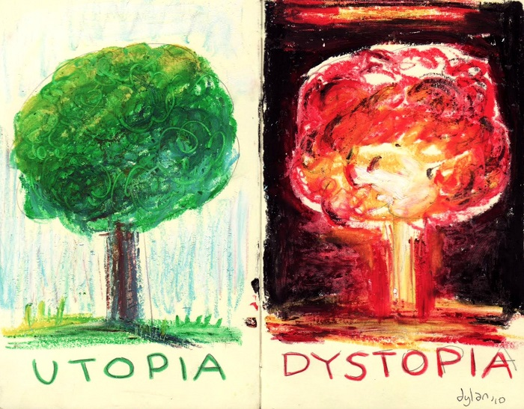
Utopia/Dystopia by Dylan Glynn
These two extremes of speculative fiction have always provided a stark contrast to modern reality, and have fascinated through their often “visionary” aspects. Anyone interested in science-fiction or modern fantasy has stumbled upon stories that paint the future in a decided color. Such stories always awaken a powerful curiosity in us, and we often close the book with a changed perspective on life.
But how many types of future are there? How do utopian storyworlds differ from the dystopian ones, when it comes to their purpose and meaning? And wherein lies the fascination for readers?
Utopia
Our Golden Age lies right before us.
Utopian fiction depicts a future in which humanity has reached a state of balance and peace, and where all life is valued and maintained. There is no more suffering and injustice, no more ignorance and violence. We have reached our full potential. The overarching message of utopian stories is one of hope and faith in humanity. Utopias remind us of our inherent instinct to crave peace, to regenerate and to evolve past our short-comings.
The grandest categories of utopian fiction (which can also be found—profoundly altered—in dystopian fiction) are the following:
Ecological Utopia
Depicts a way of life in which man is close to nature, respects and protects it, and all life is in harmony. Ecological utopias are often marked by a strong message encouraging unity with nature—both external, and internal (human nature).
Economic Utopia
Society has evolved toward an equal distribution of goods, the abolition of money and unpleasant or forced labor. Society enjoys an increased value attributed to arts, sciences and individualism. All efforts to improve life are voluntary, joint efforts, and there is no such thing as personal profit.
Political Utopia
Frequently marked by world peace (or even galactic peace), oneness and the abolition of cultural, racial and gender-based prejudices.
Spiritual Utopia
A future in which humanity has evolved past its basic needs, and is united by a common aspiration to reach enlightenment. This kind of utopia can have a religious flavor or not, but the central message is one of departure with physical nature and dedication to spiritual well-being, or a higher plane of existence.
Science and Technology Utopia
Humanity has solved all of its problems and has expanded beyond its old limits with the help of sensibly developed and used technology. In the case of self-conscious technology (such as intelligent robots or incorporeal AIs), there is a peaceful coexistence with humans and sometimes even equality in rights, though usually technology reveres and chooses to serve mankind.
Dystopia
Our Golden Age is long buried in our ashes.
Dystopian fiction depicts a future in which humanity has fallen into decline and ruin, and where life and nature are recklessly exploited and destroyed. The overarching message of dystopian stories is one of warning and mistrust in humanity. Dystopias criticize current trends through an exaggeration of their consequences.
Ecological Dystopia
Humanity has destroyed nature and/or our relationship to it. Ecological dystopias range from partial or total estrangement from nature, to the catastrophic destruction of our natural environment, up to where it can no longer sustain life.
Economic Dystopia
One or more large corporations completely rule the world, to the detriment of mankind. They can dominate the human mind through manipulation, propaganda, intrusive advertisement and even through implanted technology, or they can dominate the human life through absolute control of resources and a strict limitation of available comforts.
Political Dystopia
The government is the root of all evil. It can be the government of a single nation, or a global government, in which case dystopia crushes an otherwise utopian premise of unity. In political dystopias, society is controlled and limited by the very institutions that are supposed to protect it, ranging from presidents down to policemen. Personal freedom is a myth, trust is a commodity no one can afford, and the government disregards human rights down to treating people like livestock.
Spiritual Dystopia
You could call this type of dystopia “a dangerous idea gone viral”, but it comes in many shapes and sizes. Generally, it treats a future in which society is controlled by a dangerous ideology or religion which slowly destroys everything humanity has built along the road.
Science and Technology Dystopia
Contrary to a economic and political dystopia where a bunch of people control all others by means of technology, technological dystopia deals with the consequences of technology itself ravaging our lives. It ranges from man-slaughtering robots and man-enslaving AIs, to humankind becoming entirely dependent upon technology to accomplish even the simplest tasks. A variant of this kind of dystopia is the science-turned-rogue kind, where usually a virus or genetic modification destroys humanity.

Of course there are many stories that combine elements from different types of utopias or dystopias, and some that even successfully mix the two. Yet, it’s the extremes that polarize the audience the most, and draw the most attention.
But what’s the fascination with these absolutes?
Why do we love to dive into such extremes, even if for only a day or two (okay, a week or two, if the book is door-stopper)? Is it the escapism? The vision of a future come true between the pages? The possibilities to explore the consequences of our ways without actually being affected by them? Or maybe it’s just the fascination with society models that differ from ours, despite the common foundation. Whatever it is, utopian and dystopian fiction exert their very own kind of fascination from a psychological point of view, and therefor attract very different audiences.
To simplify very roughly, I’d say utopian fiction, with its focus on the full realization of human potential and the appreciation of nature, typically attracts optimistic adults, who’d love to see the faults of our past undone. It attracts the idealists and visionaries among us, who seek inspiration to do good or simply to renew their hope in mankind. Utopian fiction is more philosophical and cerebral, and thus appeals to the thinkers and dreamers among readers.
Dystopian fiction, on the other hand, is much more attractive to young adults and teenagers, who often feel oppressed by their environment and empathize with the dystopian protagonists’ fight against extreme odds. Fans of dystopian fiction are usually in it for the thrill and danger, for the horrors that let their own life—however miserable at the time—feel like a blessing. And of course dystopian fiction also attracts the more cynical and pessimistic adults among us, who secretly wish to see their fears realized, but preferably not in reality; who subconsciously seek to learn from the experiences of others and keep their awareness sharp.
Maybe we’re seeking ways to understand where we’re headed, to compare the advantages and disadvantages of our decisions and remind ourselves of the huge impact we have on our world and our future. Maybe it’s the desire to understand our present and change it, that lets us envision such futures. Maybe it’s simply our love for the otherworldliness of fictional realities that draws us toward utopias and dystopias. But regardless, they are the most impressive visions we create, and as such, they will always draw us in and release us with a deeper understanding of ourselves.
What’s your preferred type of futuristic story? Do you like utopias more, or dystopias?

http://www.veronicasicoe.com/blog/2013/04/utopia-and-dystopia-the-many-faces-of-the-future/

